Collision Cross Sections for iPIC Simulations

Overview of Results

Collision mechanisms have been grouped into four groups:
- Rotational
- Vibrational
- Electronic & Dissociation
- Ionization
The fits to the mean energy loss (dashed lines) per collision are seen below, with ionization separated.
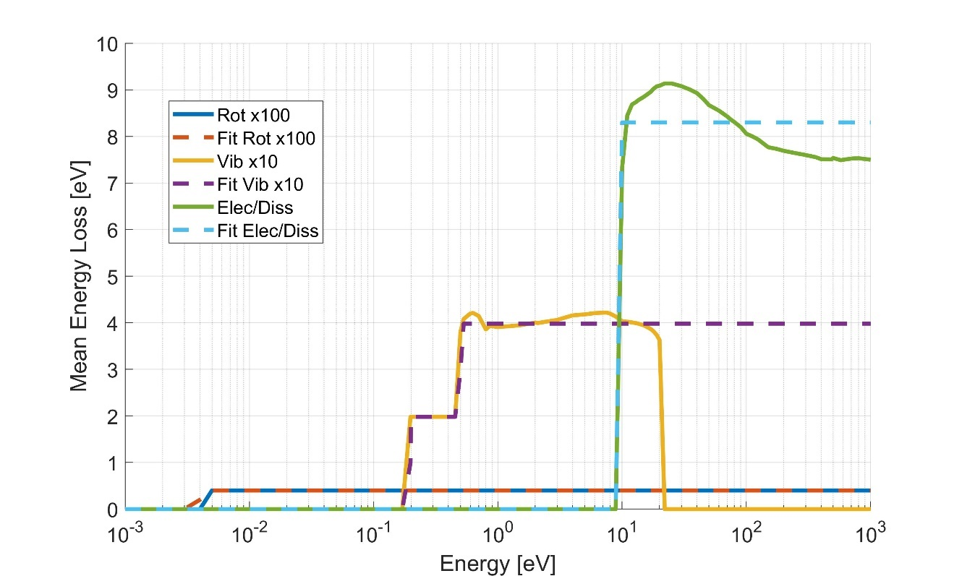
Figure 1: Mean energy loss per collision for the combined excitation cross sections. Mean energy loss is weighted by the Loss Rate of each process.
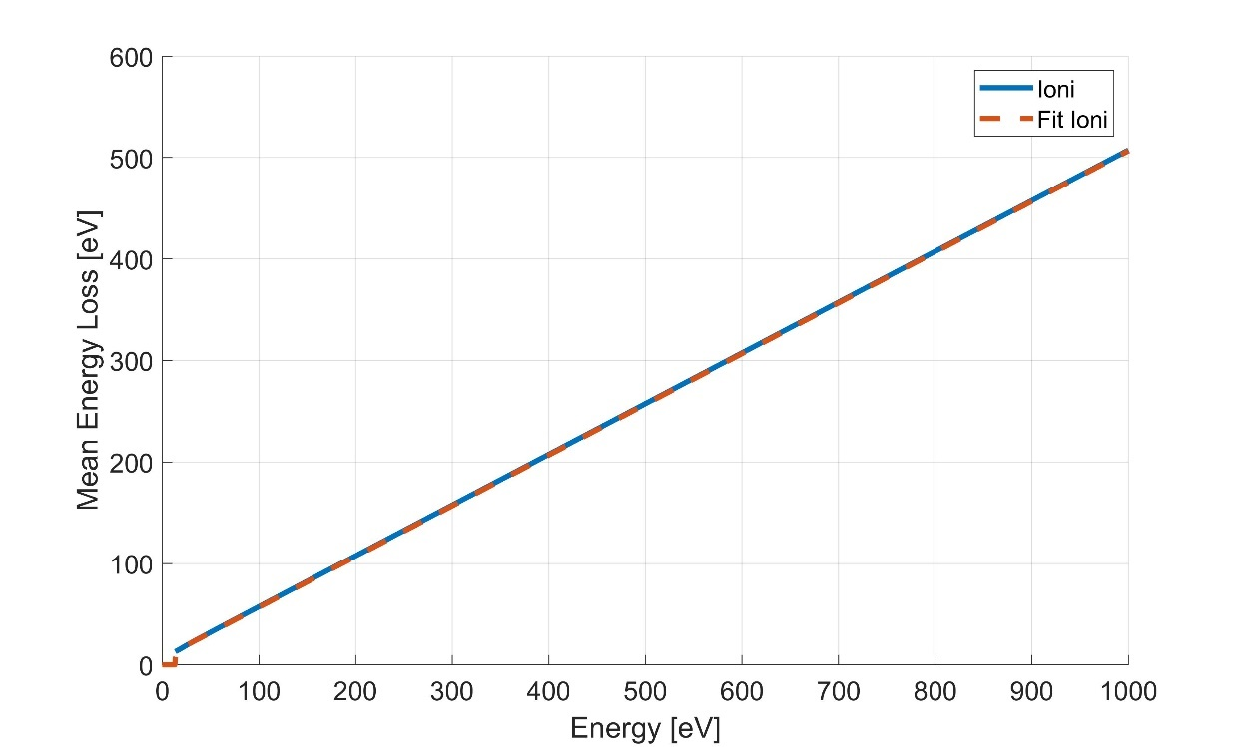
Figure 2: Mean energy loss per collision for each ionization collision.
The fits to the effective cross Sections (dotted) for each of the four processes are shown below:

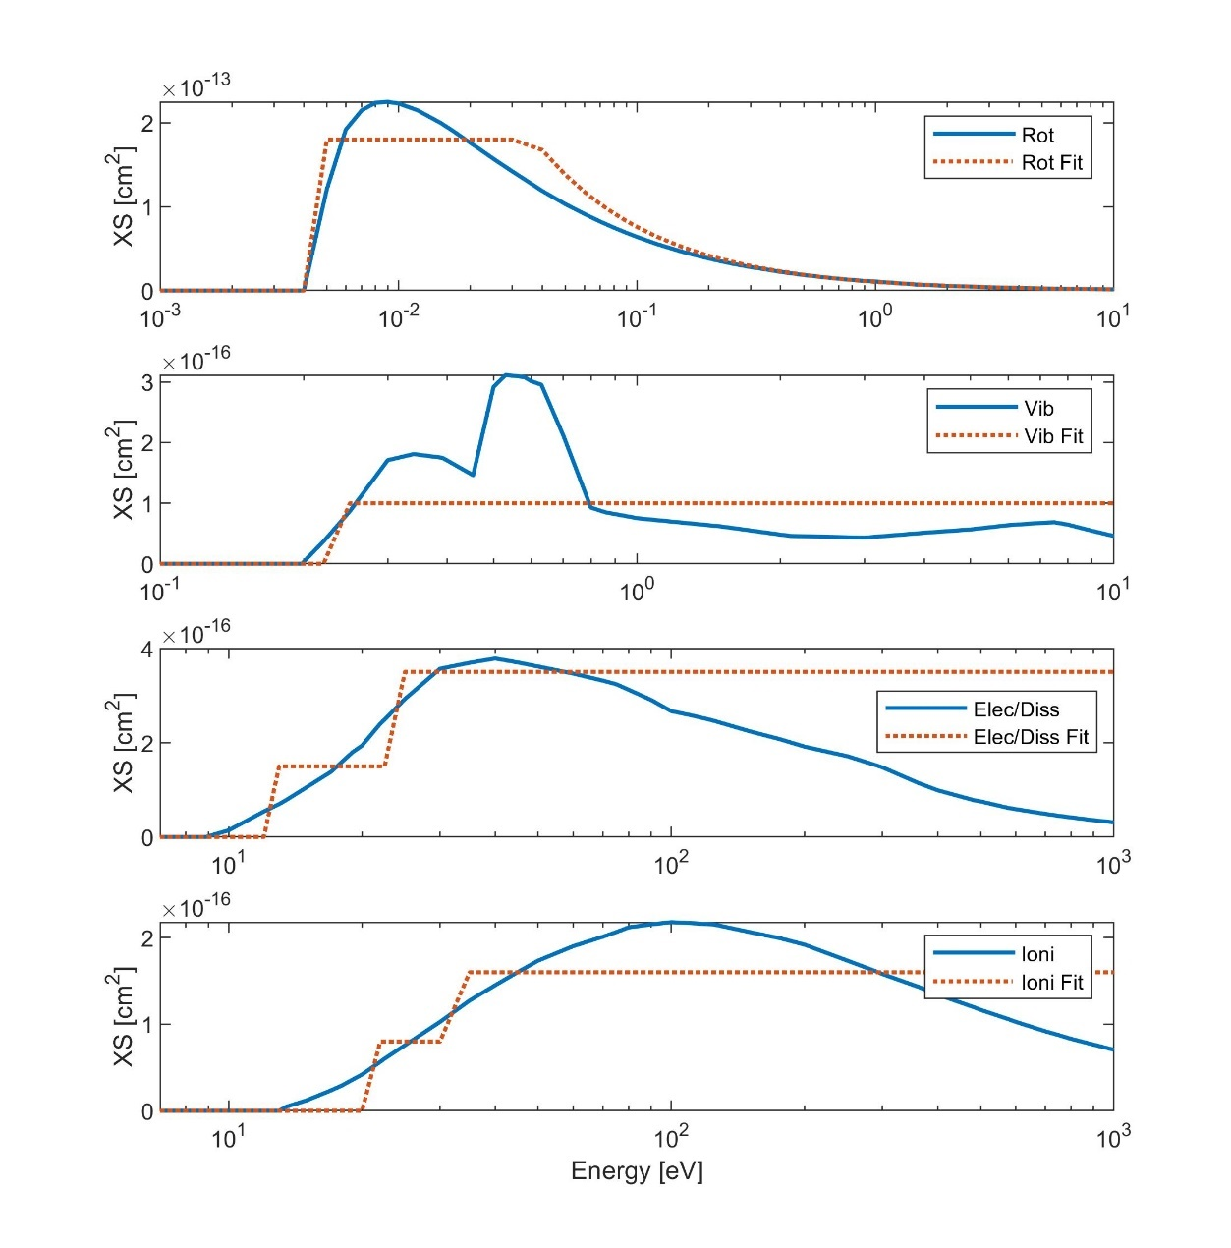
Figure 3: Fits to the effective cross section of each set of inelastic collision processes. Fits given by the dotted lines. (a) Rotational, (b) Vibrational, (c) Electronic & Dissociation, (d) Ionization

Original Cross Sections

The full set of cross sections comprises 12 processes which are outlined below: (E_th ref is the same as for XS unless stated otherwise).
Process | E_th [eV] | References
Elastic Coll | 0 | from 1eV to 100 eV Itikawa & Mason, 2005 (Table 4), higher than 100eV, Munoz et al, 2007, below 1eV, set constant to high value of 50e-16
Rotational J = 0->1 | 0.004 | Itikawa and Mason, 2006
H2O-vibrational-excitation-v=010 | 0.198 | Itikawa and Mason, 2005
H2O-vibrational-excitation-v=100and001 | 0.453 | Itikawa and Mason, 2005
Electronic | 10 (assumed average) | Thorn, 2008 and assumptions of linear decrease after 100 eV
Dissociation | 7 [Harb et al (2001) | Itikawa and Mason – 2005. Extended to higher energies with power law.
H₂O+ | 12.62 (NIST) | Itikawa & Mason 2005 Table 11
OH+ | 18.1 (NIST) | Itikawa & Mason 2005 Table 11
O+ | 19.0 (NIST) | Itikawa & Mason 2005 Table 11
H₂+ | 20.7 (NIST) | Itikawa & Mason 2005 Table 11
H+ | 16.95 (NIST) | Itikawa & Mason 2005 Table 11
O++ | 54.1 | E_th from O+ and second ionization potential of Oxygen (35.1eV). Itikawa & Mason 2005 Table 11

The Cross Sections are plotted below.

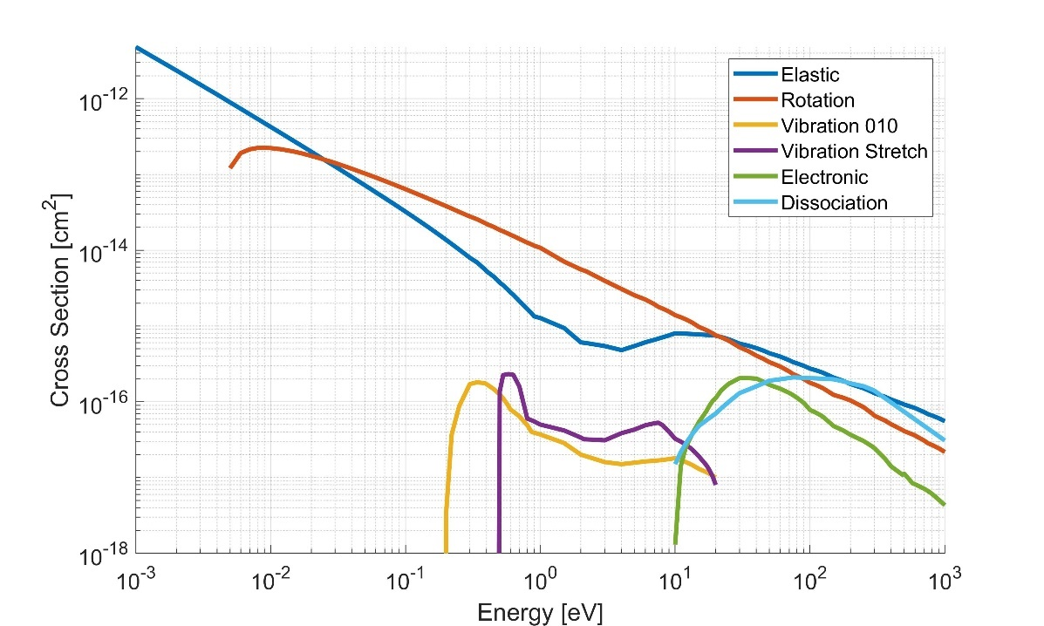
Figure 4: Cross sections of electron impacts on H2O molecules.
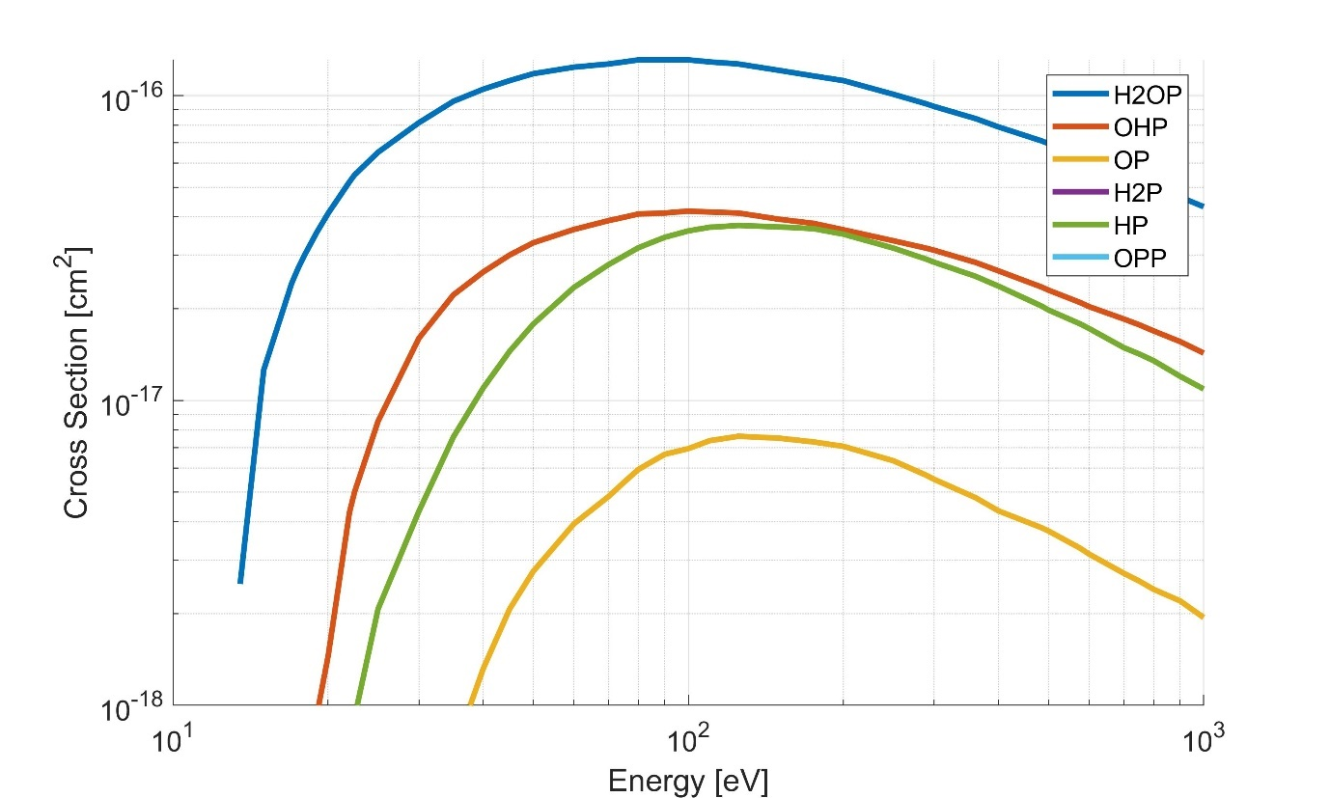
Figure 5: Cross Sections of ionization processes caused by electron impact on H2O molecules. The lines are labelled by the ion produced by this collision process.
The energy loss by the incident electron in each excitation collision is assumed to be the threshold energy of the process occurring. For ionization, it is assumed the energy of the incident electron is split equally between the outgoing electrons, once the threshold energy has been removed.

Combining Cross Sections

The cross sections are grouped by threshold energy. The mean energy loss for a set of cross sections is weighted by the loss rate of the process, which is given by
$$LR\left(E\right)=E_{Loss}×σ\left(E\right)$$
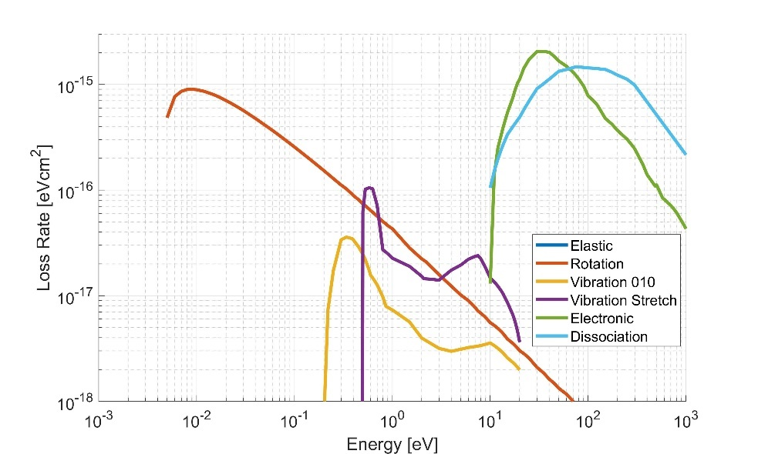
Figure 6: Loss rate of each excitation collision process. Elastic collisions not seen as no energy is lost.

The effective cross section of each group is given by
$$σ_{eff}\left(E\right)=\frac{\sum_{i}{LR_{i}\left(E\right)}}{\hat{E_{loss}}}$$
Where the sum is over the processes included in each group.
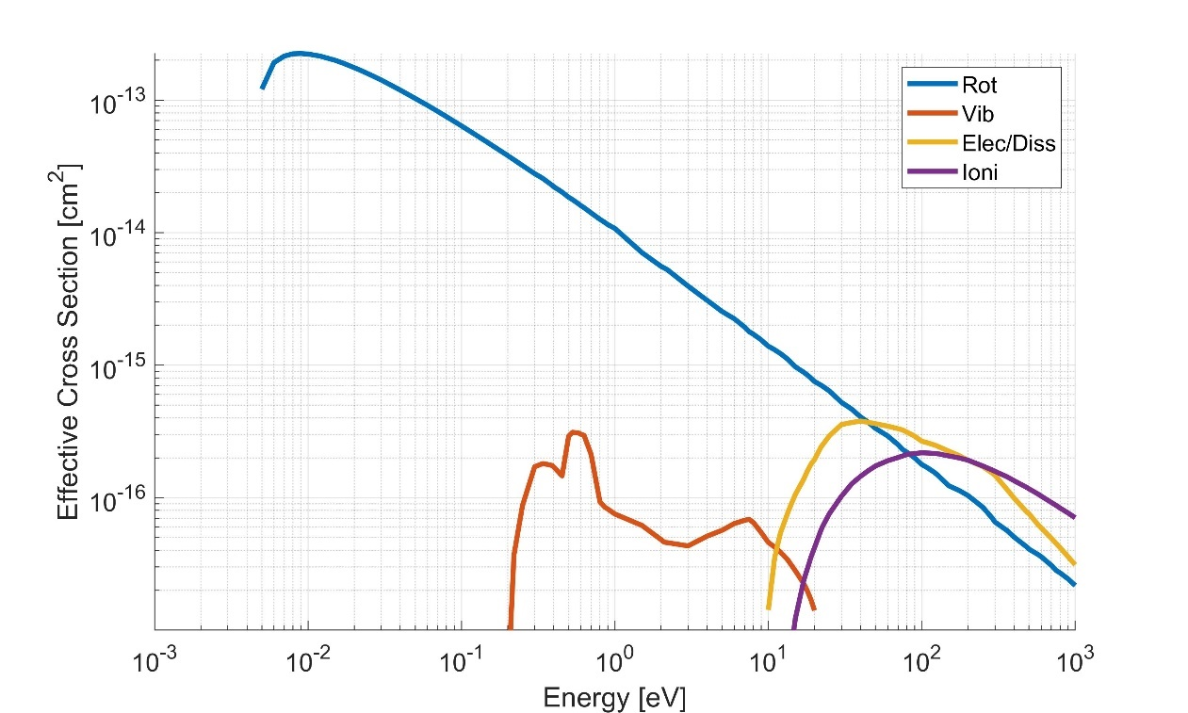
Figure 7: Effective Cross sections for the four groups of inelastic collisions

Fitting the effective Cross Sections

The energy loss per collision has been fitted with step functions for each process (see Also Figs. 1 & 2)
Process | Energy Range [eV] | ${\hat{E}}_{Loss}$ [eV]
Rotational | >0.004 | 0.004
Vibrational | 0.198 – 0.46 | 0.198
Vibrational | 0.46-12 | 0.4
Elec/Diss | >9 | 8.3
Ionization | >13.5 | $$0.5*\left(13.5+E\right)$$

The fits to the effective cross section are also given by a series of steps. The dissociation and ionization cross sections, which extend to higher energies, have been fit more closely at lower energies (tens of eV). In previous runs of the iPIC model there have been few electrons observed at high energies (>200eV) so divergence at high energies shouldn’t affect the cooling significantly.
Process | Energy Range [eV] | $$σeff\left(E\right) [cm^2]$$
Rotational | 0.004 - 0.03 | 1.8e-13
Rotational | 0.03 -12 (could cut off at ~4eV) | $AE^{B}$ with $A=1.035×{10}^{-14}$  And $B =-0.8651$
Vibrational | 0.22 – 12 | $${10}^{-16}$$
Elec/Diss | 12-25 | $$1.5×{10}^{-16}$$
Elec/Diss | >25 (could stop at ~100eV) | $$3.5×{10}^{-16}$$
Ionization | 20 – 35 | $$8×{10}^{-17}$$
Ionization | >35 | $$1.6×{10}^{-16}$$

These give the fits to the effective cross section seen in Fig. 3.
The fits to the loss rate for each group of processes are shown below. The energy loss through the vibrational mode is slightly overestimated in the range 1-4eV.
The overestimation of the dissociation loss rate is unimportant at high energies > 100 eV as this is dwarfed by the energy loss through ionization.
